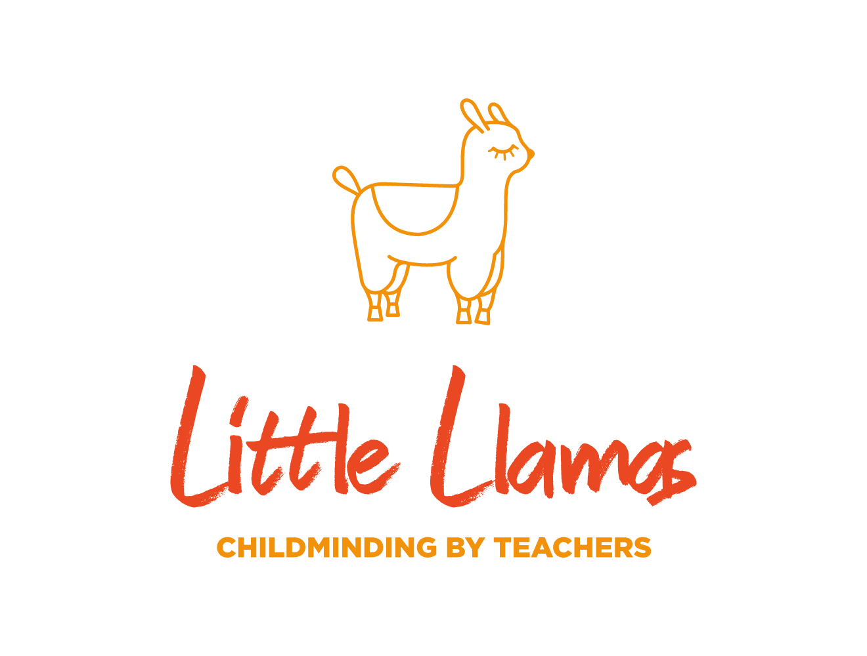
Medicines Policy
Rationale
We are committed to ensuring that children with short or long-term medical conditions receive the care and medication needed for them to participate in the setting if they are well enough to attend. In order to achieve this, we are willing to administer medication, providing we have the medical or technical knowledge to do so and have written parental permission.
Procedure
Medicines will not normally be administered unless a doctor, dentist, nurse or pharmacist has prescribed them for the child. We will only administer prescribed medicine for the child it is prescribed for. We will not administer any medication containing aspirin unless a doctor has prescribed it.
Non-prescription medication may be given with prior written permission from parents/carers when there is a health reason to do so. For non-prescription medication named on the consent form, you will be contacted before we administer the medicine to your child.
All medication must be supplied in the original packaging and clearly labelled with your child’s name and will be stored according to product instructions.
The first dose of each medicine should always be given at home with sufficient time to observe the child’s responses to the medicine before the child is brought to my setting. Please keep your child at home for 48 hours after administering their first dose of antibiotics to ensure they have no reactions.
Where possible, please try to arrange that medication will only be administered at home before and after attending our setting.
Where medication is given as on-going treatment for health conditions such as Asthma, diabetes etc, a health care plan will need to be written and signed by a health care professional. Any relevant training will need to be had by all members of staff at Little Llamas before the child is to start or return to our setting.

Childminder’s Signature:
Emma Hacker & Lauren Tolan

Date:
1.8.23
Reviewed 1.8.24
Reviewed 1.8.25

